My Favorite Dolls
My earliest recollections of childhood toys are about the dolls I played with. The first doll I remember was rolling up a knitted rag rug and pretending it was my doll. I was probably three years old at the time and lived on a ten-acre farm with my parents, a brother and two sisters. All of we children loved to play house and as I was the older of the girls, always got to be the “mother.” It was my job to keep the “children” occupied – so I invented the “rug dolls” for them to play with.
The next doll I recall was a large cloth doll with a molded head. During one of our play sessions it ended up in the oven, put there by my brother. We all cried when we saw the doll all melted and scorched brown.
Later on when I was about eight, my sister and I received a “Schöenhut” wooden doll. I learned to sew by making clothes for that doll.
I had other dolls, celluloid, glass-headed, and such but these three dolls were the ones I remember being attached to. We kept the wooden doll in our family until I was in college and y mother gave it away to three little girls who lived across the alley from us – I’d give anything to have that doll today!
Elizabeth Wing Bangerter, 3-25-85
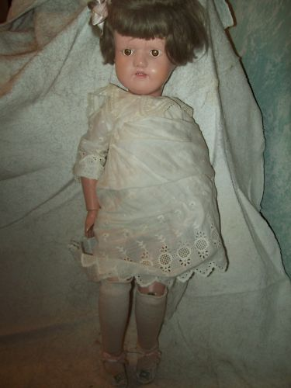
Schoenhut doll

