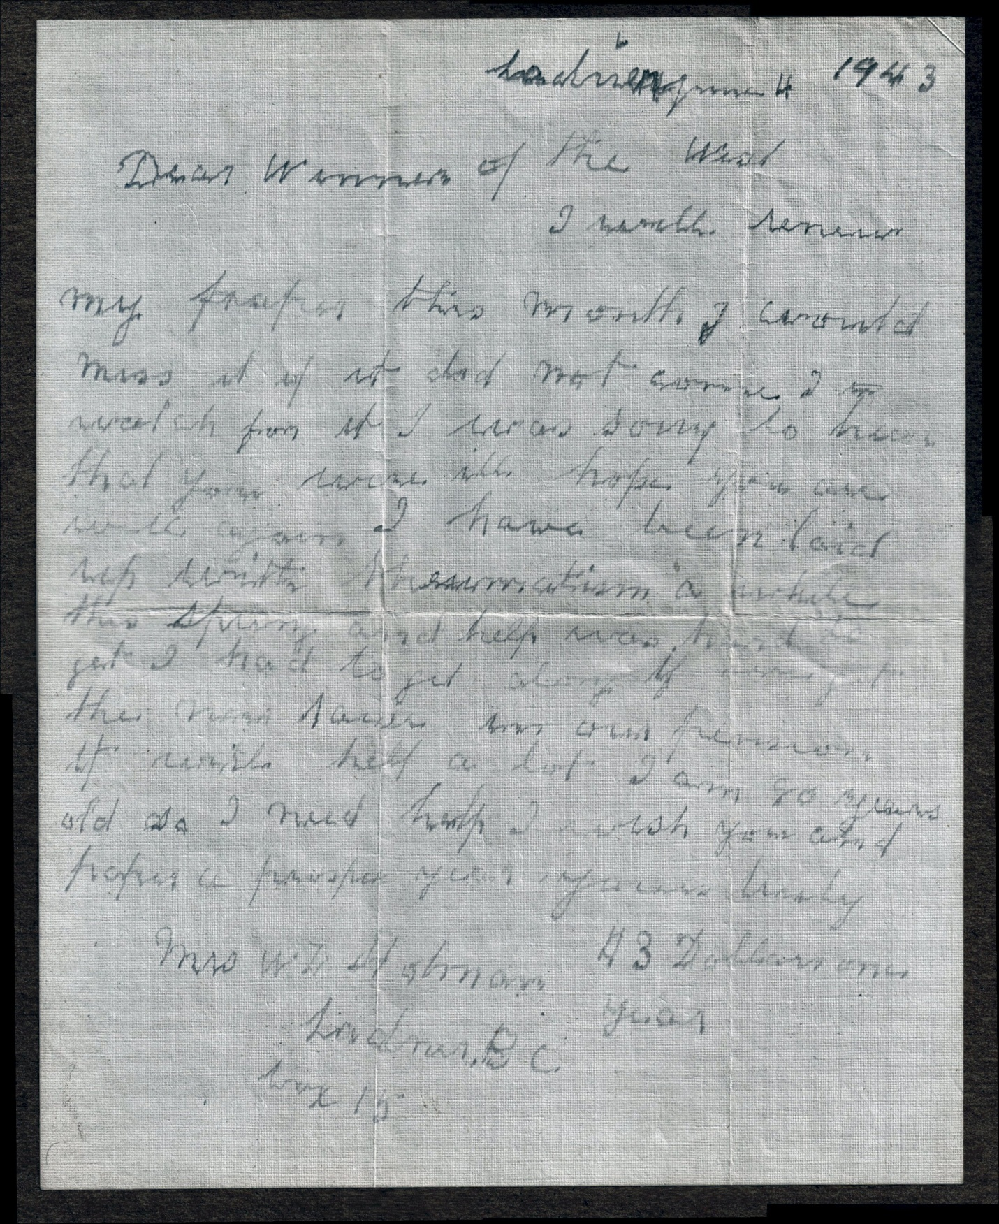

*(punctuation added for clarity)*

Ladner June 4 1943

Dear Winners of the West

I will renew my paper this month. I would miss it if it did not come. I do watch from it. I was sorry to hear that you were ill, hope you are well again. I have been laid up with rheumatism a while this spring and help was hard to get. I had to get along. If we get the new raise in our pension it will help a lot. I am 80 years old so I need help. I wish you and paper a prosper year. Yours truly

Mrs WL Harmon

Ladner BC

Box 15

$3 Dollars one year